CHAPTER 28 Exercises
You can find assignments from the end of each chapters. For example solutions, see Appendix D.
Tips for exercises
- Add clear comments explaining each line or section of code. This enhances understanding for both you and others, aids in debugging, facilitates code reuse, and promotes transparency.
- Interpret results by comparing them to existing literature. Summarize key findings to ensure they are easily understandable, even for those without advanced expertise in data analytics.
- Avoid hard-coding values. Instead, define variables at the start of the code chunk to make parameter adjustments easier and improve code reusability.
28.1 Basics of R/Bioconductor
Bioconductor training material has been contributed to Carpentries. You can check the following lessons for basic background of R and Bioconductor.
- Introduction to data analysis with R and Bioconductor
- Introduction to the Bioconductor project
29 Support
29.1 FindingPheno
This project received funding from the European Union’s Horizon 2020 research and innovation programme under grant agreement No 952914 (FindingPheno).
29.2 Online support
For online support on installation and other matters, join us on:
- GitHub discussion forum
- Bioconductor Zulip
- Mailing list
29.3 Code of Conduct
We support the Bioconductor Code of Conduct. The community values an open approach to science that promotes:
- sharing of ideas, code, software and expertise
- a kind and welcoming environment, diversity and inclusivity
- community contributions and collaboration
30 Resources
30.1 Data containers
30.1.1 Data container documentation
- SingleCellExperiment (Lun and Risso 2020)
  - Online tutorial
  - Project page
  - Publication
- SummarizedExperiment (Morgan et al. 2020)
  - Online tutorial
  - Project page
- TreeSummarizedExperiment (Huang 2020)
  - Online tutorial
  - Project page
  - Publication
- MultiAssayExperiment (Ramos et al. 2017)
  - Online tutorial
  - Project page
  - Publication
Lun, Aaron, and Davide Risso. 2020. SingleCellExperiment: S4 Classes for Single Cell Data.
Morgan, Martin, Valerie Obenchain, Jim Hester, and Hervé Pagès. 2020. SummarizedExperiment: SummarizedExperiment Container. https://bioconductor.org/packages/SummarizedExperiment.
Huang, Ruizhu. 2020. TreeSummarizedExperiment: A S4 Class for Data with Tree Structures.
30.1.2 Other relevant containers
- DataFrame which behaves similarly to data.frame, yet efficient and fast when used with large datasets.
- DNAString along with DNAStringSet,RNAString and RNAStringSet efficient storage and handling of long biological sequences are offered within the Biostrings package (Pagès et al. 2020).
- GenomicRanges ((Lawrence et al. 2013)) offers an efficient representation and manipulation of genomic annotations and alignments, see e.g. GRanges and GRangesList at An Introduction to the GenomicRangesPackage.
Pagès, H., P. Aboyoun, R. Gentleman, and S. DebRoy. 2020. Biostrings: Efficient Manipulation of Biological Strings. https://bioconductor.org/packages/Biostrings.
Lawrence, Michael, Wolfgang Huber, Hervé Pagès, Patrick Aboyoun, Marc Carlson, Robert Gentleman, Martin Morgan, and Vincent Carey. 2013. “Software for Computing and Annotating Genomic Ranges.” PLoS Computational Biology 9. https://doi.org/10.1371/journal.pcbi.1003118.
NGS Analysis Basics provides a walk-through of the above-mentioned features with detailed examples.
30.1.3 phyloseq: an alternative container for microbiome data
The phyloseq package and class became the first widely used data container for microbiome data science in R. Many methods for taxonomic profiling data are readily available for this class. We provide here a short description how phyloseq and Experiment classes relate to each other.
assays : This slot is similar to otu_table in phyloseq. In a SummarizedExperiment object multiple assays, raw counts, transformed counts can be stored. See also (2017) for storing data from multiple experiments such as RNASeq, Proteomics, etc. rowData : This slot is similar to tax_table in phyloseq to store taxonomic information. colData : This slot is similar to sample_data in phyloseq to store information related to samples. rowTree : This slot is similar to tree.file in phyloseq to store phylogenetic tree.
Ramos, Marcel, Lucas Schiffer, Angela Re, Rimsha Azhar, Azfar Basunia, Carmen Rodriguez Cabrera, Tiffany Chan, et al. 2017. “Software for the Integration of Multiomics Experiments in Bioconductor.” Cancer Research. https://doi.org/10.1158/0008-5472.CAN-17-0344.
In this book, you will encounter terms such as FeatureIDs and SampleIDs. FeatureIDs : These are basically OTU/ASV ids which are row names in assays and rowData. SampleIDs : As the name suggests, these are sample ids which are column names in assays and row names in colData. FeatureIDs and SampleIDs are used but the technical terms rownames and colnames are encouraged to be used, since they relate to actual objects we work with.
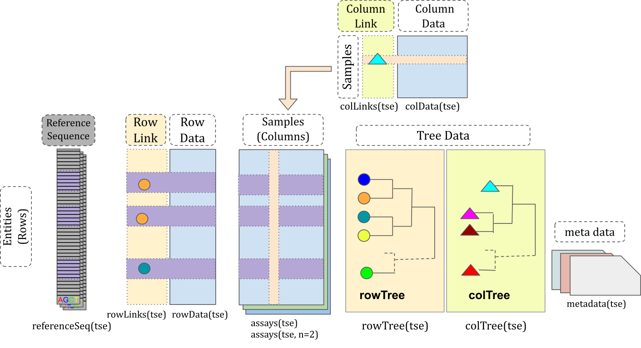
30.1.3.1 Benchmarking TreeSE with phyloseq
TreeSE objects can be converted into phyloseq objects and vice versa, therefore it is possible to compare the two containers in terms of computational efficiency. Remarkably, TreeSE and phyloseq were benchmarked against one another in mia v1.2.3 and phyloseq v1.38.0, respectively. 5 standard microbiome analysis operationswere applied to 4 datasets of varying size with both containers. In a nutshell, TreeSE and phyloseq showed a similar performance for datasets of small and medium size for most of the operations. However, TreeSE performed more efficiently as the size of the datasets increased. Further details on such results can be found in the benchmarking repository.
30.1.3.2 Resources on phyloseq
The phyloseq container provides analogous methods to TreeSE. The following material can be used to familiarize with such alternative methods:
- List of R tools for microbiome analysis
- phyloseq (McMurdie and Holmes 2013)
- microbiome tutorial
- microbiomeutilities
- phyloseq/TreeSE cheatsheet
- Bioconductor Workflow for Microbiome Data Analysis: from raw reads to community analyses (Callahan et al. 2016).
McMurdie, PJ, and S Holmes. 2013. “Phyloseq: An r Package for Reproducible Interactive Analysis and Graphics of Microbiome Census Data.” PLoS ONE 8: e61217. https://doi.org/10.1371/journal.pone.0061217.
Callahan, Ben J., Kris Sankaran, Julia A. Fukuyama, Paul J. McMurdie, and Susan P. Holmes. 2016. “Bioconductor Workflow for Microbiome Data Analysis: From Raw Reads to Community Analyses [Version 2; Peer Review: 3 Approved].” F1000Research 5: 1492. https://doi.org/10.12688/f1000research.8986.2.
30.2 R programming resources
30.2.1 Base R and RStudio
If you are new to R, you could try swirl for a kickstart to R programming. Further support resources are available through the Bioconductor project (Huber et al. 2015).
- Base R and RStudio cheatsheets
- Package-specific cheatsheets
- Visualization with ggplot2
- R graphics cookbook
30.2.2 Bioconductor Classes
Introduction to data analysis with R and Bioconductor; Carpentries introduction, including R & RStudio installation instructions
S4 system
S4 class system has brought several useful features to the object-oriented programming paradigm within R, and it is constantly deployed in R/Bioconductor packages (Huber et al. 2015).
Huber, W., V. J. Carey, R. Gentleman, S. Anders, M. Carlson, B. S. Carvalho, H. C. Bravo, et al. 2015. “Orchestrating High-Throughput Genomic Analysis with Bioconductor.” Nature Methods 12 (2): 115–21. http://www.nature.com/nmeth/journal/v12/n2/full/nmeth.3252.html.
Online Document:
- Hervé Pagès, A quick overview of the S4 class system.
- Laurent Gatto, A practical tutorial on S4 programming
- How S4 Methods Work (J. Chambers 2006)
Chambers, JM. 2006. “How S4 Methods Work.” Technical report.
Books:
- John M. Chambers. Software for Data Analysis: Programming with R. Springer, New York, 2008. ISBN-13 978-0387759357 (J. M. Chambers 2008)
- I Robert Gentleman. R Programming for Bioinformatics. Chapman & Hall/CRC, New York, 2008. ISBN-13 978-1420063677 (Gentleman 2008)
Chambers, John M. 2008. Software for Data Analysis: Programming with r. Vol. 2. Springer.
Gentleman, Robert. 2008. R Programming for Bioinformatics. CRC Press.
30.3 Reproducible reporting with Quarto
30.3.1 Learn Quarto
Reproducible reporting is the starting point for robust interactive data science. Perform the following tasks:
- If you are entirely new to Quarto, take this short tutorial to get introduced to the most important functions within Quarto. Then experiment with different options from the Quarto cheatsheet.
- Create a Quarto template in RStudio, and render it into a document (markdown, PDF, docx or other format). In case you are new to Quarto, its documentation provides guidelines to use Quarto with the R language (here) and the RStudio IDE (here).
- Further examples are tips for Quarto are available in this online tutorial to interactive reproducible reporting.
30.3.2 Additional material on Rmarkdown
Being able to use Quarto in R partly relies on your previous knowledge of Rmarkdown. The following resources can help you get familiar with Rmarkdown:
- Online tutorial
- Cheatsheet
- Documentation
- Dr. C Titus Brown’s tutorial
Figure sources:
Original article
- Huang R et al. (2021) TreeSummarizedExperiment: a S4 class for data with hierarchical structure. F1000Research 9:1246. (Huang et al. 2021)
Huang, Ruizhu, Charlotte Soneson, Felix G. M. Ernst, et al. 2021. “TreeSummarizedExperiment: A S4 Class for Data with Hierarchical Structure [Version 2; Peer Review: 3 Approved].” F1000Research 9: 1246. https://doi.org/10.12688/f1000research.26669.2.
Reference Sequence slot extension
- Lahti L et al. (2020) Upgrading the R/Bioconductor ecosystem for microbiome research F1000Research 9:1464 (slides).
30.3.3 Further reading
The following online books provide good general data science background:
- (Data science basics in R](https://r4ds.had.co.nz)
- (Modern Statistics for Modern Biology)[https://www.huber.embl.de/msmb/] open access book (Holmes S, Huber W)
- The Bioconductor project (background on the Bioconductor project; Carpentries workshop)
31 Contributions
Core team
Contributions to this Gitbook from the various developers are coordinated by:
- Leo Lahti, DSc, professor in Data Science in the Department of Computing, University of Turku, Finland, with a focus on computational microbiome analysis. Lahti obtained a doctoral degree (DSc) from Aalto University in Finland (2010), developing probabilistic machine learning with applications to high-throughput life science data integration. Since then, he has focused on microbiome research and developed, for instance, the phyloseq-based microbiome R package before starting to develop the TreeSummarizedExperiment / MultiAssayExperiment framework and the mia family of Bioconductor packages for microbiome data science introduced in this Gitbook. Lahti led the development of national policy on open access to research methods in Finland. He is a current member in the [Bioconductor Community Advisory] (https://bioconductor.org/about/community-advisory-board/) and runs regular training workshops in microbiome data science.
- Tuomas Borman, PhD researcher and the lead developer of OMA/mia at the Department of Computing, University of Turku.
Contributors
This work is a remarkably collaborative effort. The full list of contributors is available via Github. Some key authors/contributors include:
- Felix Ernst, PhD, among the first developers of R/Bioc methods for microbiome research based on the SummarizedExperiment class and its derivatives.
- Giulio Benedetti, scientific programmer at the Department of Computing, University of Turku. His research interest is mostly related to Data Science. He has also helped to expand the SummarizedExperiment-based microbiome analysis framework to the Julia language, implementing Board](https://bioconductor.org/about/community-advisory-board/) MicrobiomeAnalysis.jl.
- Sudarshan Shetty, PhD has supported the establishment of the framework and associated tools. He also maintains a list of microbiome R packages.
- Henrik Eckermann contributed in particular to the development of differential abundance analyses
- Chouaib Benchraka provided various contributions to the package ecosystem and the OMA book
- Yağmur Şimşek converted the miaSim R package to support the Bioconductor framework
- Basil Courbayre provided various contributions to the package ecosystem and the OMA book, in particular on unsupervised machine learning
- Matti Ruuskanen, PhD, added machine learning techniques for microbiome analysis
- Stefanie Peschel has contributed chapters on the construction, analysis, and comparison of microbial association networks.
- Christian L. Müller, group leader at the Computational Health Center, Helmholtz Zentrum München, Germany and a Professor for Biomedical Statistics and Data Science at LMU Munich. He assisted in writing the chapters on network learning and comparison.
- Shigdel Rajesh, PhD
- Artur Sannikov
- Akewak Jeba
- Himmi Lindgren
- Lu Yang
- Katariina Pärnänen
- Noah de Gunst
- Axel Dagnaud
- Ely Seraidarian
- Théotime Pralas
- Geraldson Muluh
- Jiya Chaudhary
- Elina Chiesa
- Pande Erawijantari
- Shadman Ishraq
- Sam Hillman
- Matteo Calgaro
- Basil Courbayre Dussau
- Yang Cao
- Eineje Ameh
- Domenick J. Braccia
- Renuka Potbhare
- Hervé Pagès
- Moritz E. Beber
- Vivian Ikeh
- Yu Gao
- Daniel Garza
- Karoline Faust
- Jacques Serizay converted the OMA book to the BiocBook format. This allows the OMA book to be built and distributed by Bioconductor.
- Himel Mallick, PhD, FASA, principal investigator and tenure-track faculty at Cornell University’s Department of Population Health Sciences and an adjunct faculty of Statistics and Data Science at Bowers College of Computing and Information Science. He contributed to the chapters on meta-analyses, microbe set enrichment analysis (MSEA) and multi-omics prediction and classification.
- Yihan Liu, assisted Dr. Mallick in writing the chapters on meta-anlayses, MSEA and multi-omics prediction and classification.
- Danielle Callan
- Ben Allen
- Teo Dallier
- Elliot Gaudron-Parry
- Inès Benseddik
- Jesse Pasanen
- Benjamin Valderrama contributed to the supervised machine learning chapter.

